|  |  |
| --- | --- |
| DATE | 15 October 2022 |
| PROJECT NAME | Rea Time Communication System Powered By AI For Specially Abled |
| TEAM ID | PNT2022TMID30001 |

**TECHNOLOGY ARCHITECTURE**

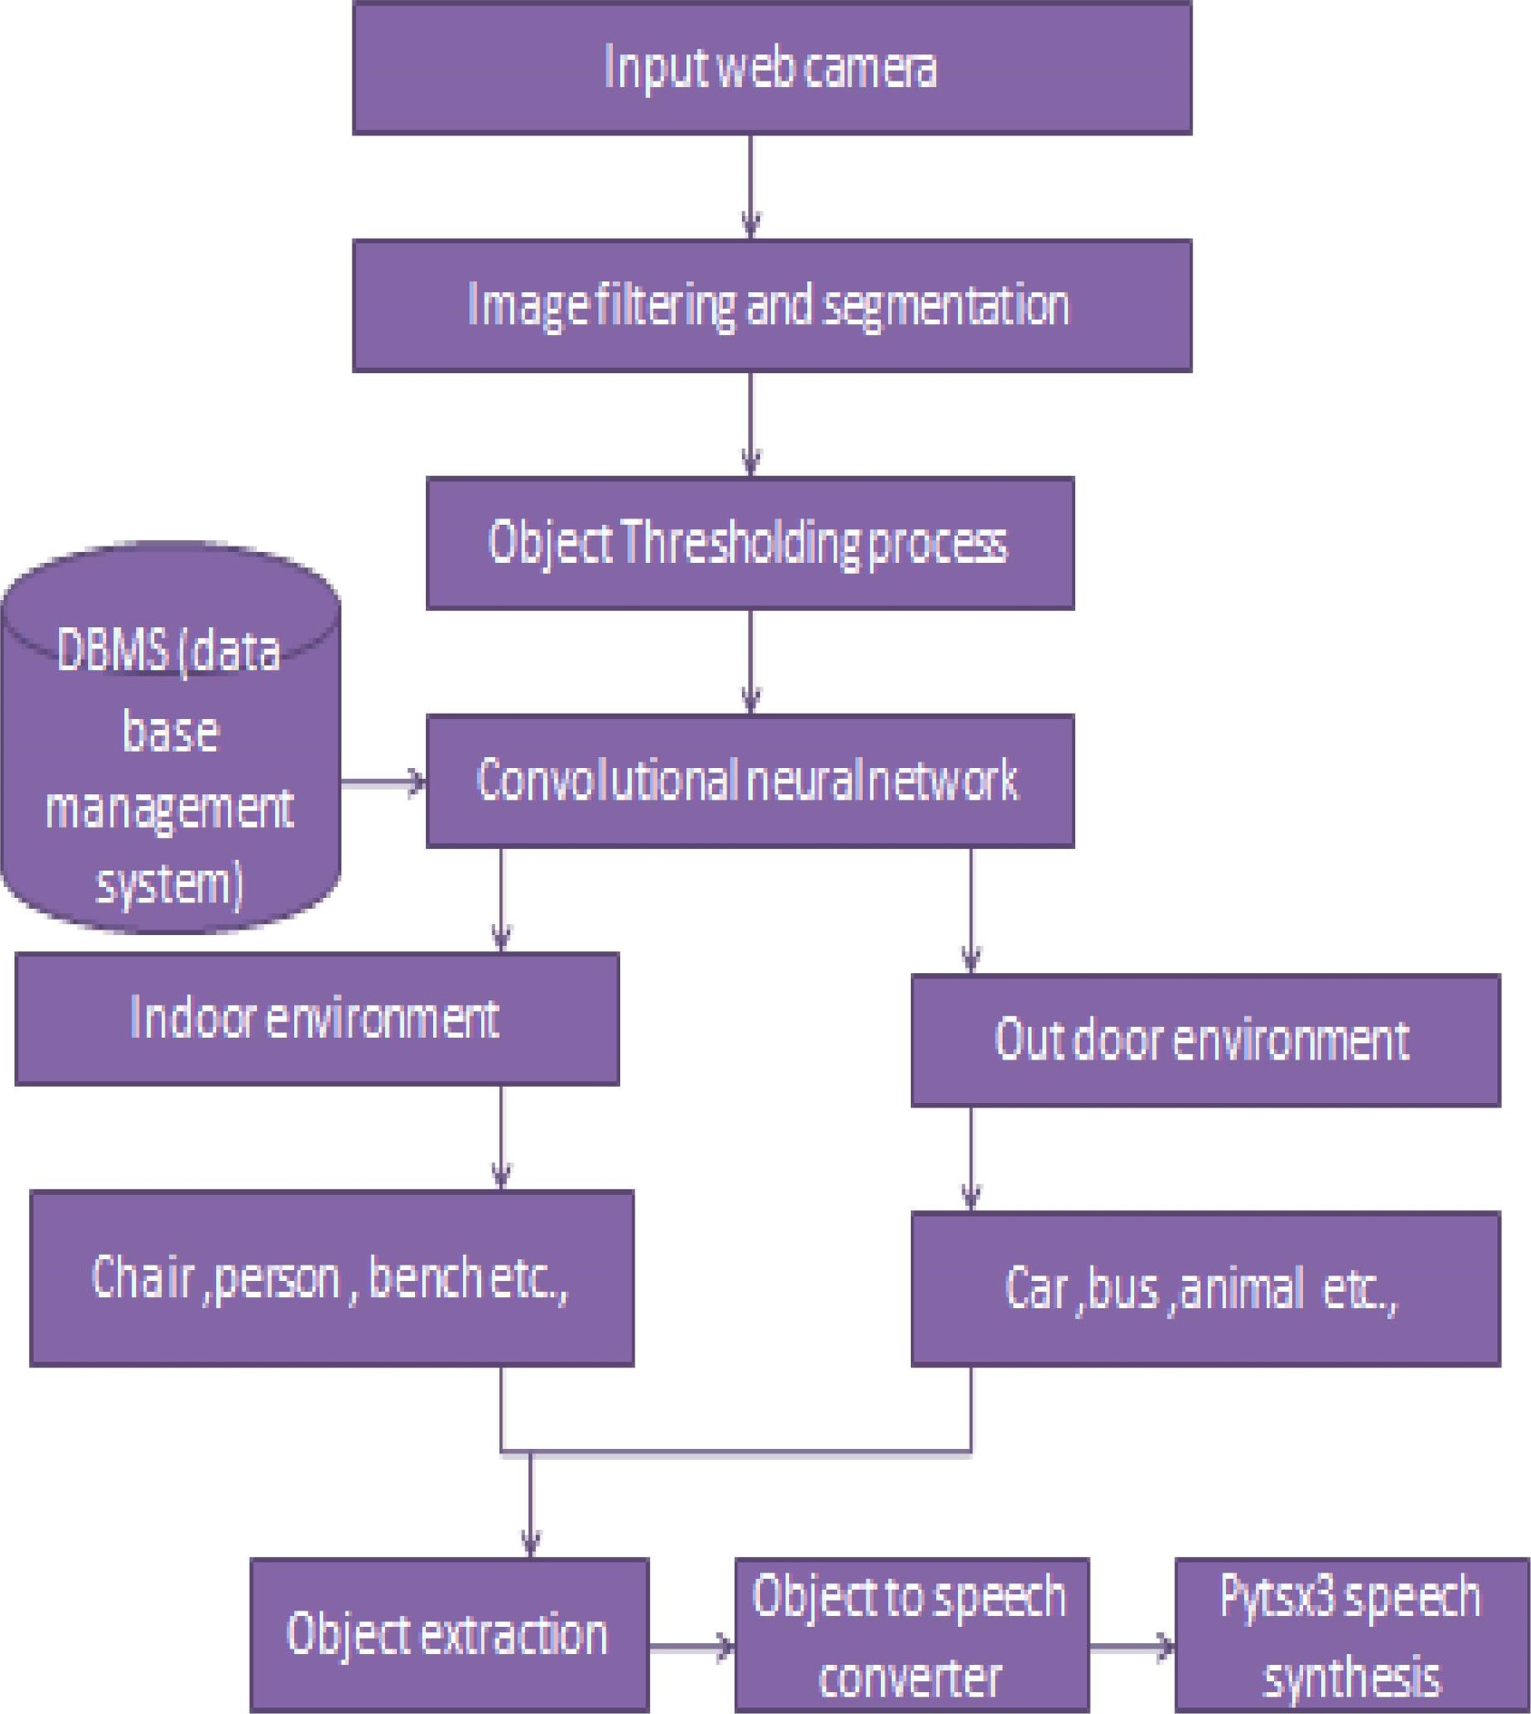

4.1